**Customer Comparison between Clock and Clearview 5Kw stoves**

**Clock Blithfield 5 Report.                             Clearview Pioneer Report**

Installed November 5th 2021.                     Installed December 23rd 2022.

Flue – 5” Flexible metal liner, Flue - same to be changed spring 2023

Connection - Top.                                         Connection – same

Fuel - Kiln dried wood with <15 moisture.  Fuel - same

**Lighting the clock**

Fire should be laid with morning sticks, new paper or firelighter, and larger sticks on top, this would not work as, as soon as lit the smoke would come into room, so tried lighting fire upside down by placing small logs on bottom, with morning  sticks etc on top and lighting the fire upside down thus allowing us not to open the door for 20-30 minutes to allow the fire to heat up to stop the smoke escaping into the room {as instructed}, this did not work as most times the fire did not take so we had to open the door to re-start the fire, allowing the smoke into the room.

**Lighting the Clearview**

Fire is laid with morning sticks, firelighters and larger sticks on top, lit.. door closed, morning sticks catch alight, fire gets established, we open the doors to place small logs on the now burning morning sticks and close the door.

NO smoke escapes into the room  at all, no need to set fire upside down and relight many times to get going.

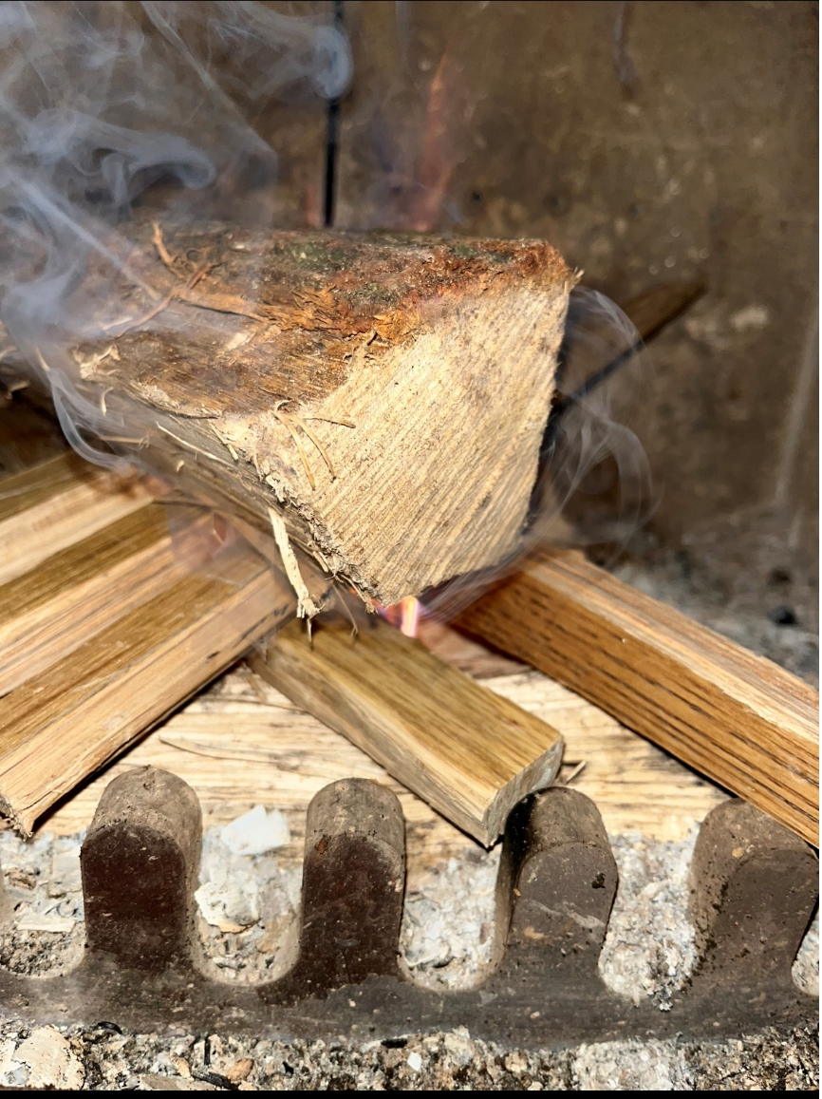

Clock after several attempts of lighting

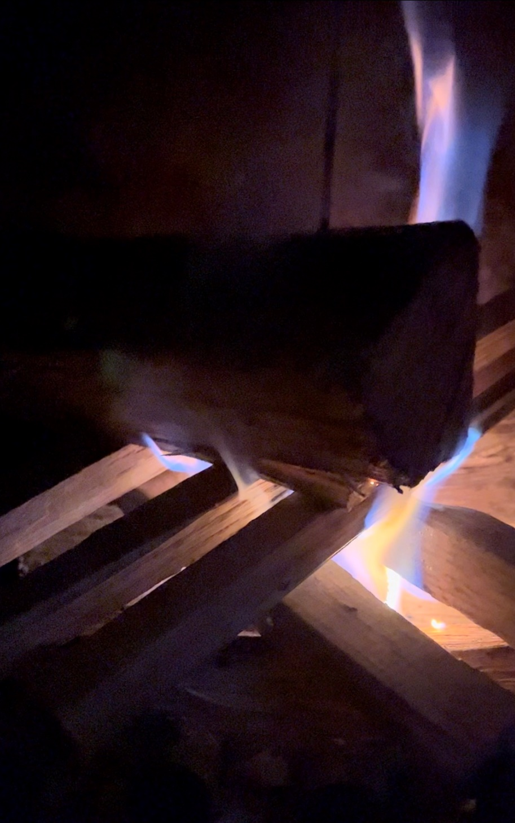

Clear view after lighting once

**Clock**

Once fire was going, it held the smoke within the fire its self, you could see it swirling around inside through the door, the glass at times would be bronzed/brown so you couldn’t actually see the flames - note we used kiln dried wood as we were told to do - although on previous fires we burnt no kiln dried wood without issue.

To reload the fire we would have to crack the door, wait 20-30 secs {with smoke seeping into  lounge], then open door fully to reload and shut as quickly as possible to stop the smoke escaping anymore than it had already. So we got to a point where we open our patio door every time before we loaded the fire and left this open for a few minutes after the fire had been loaded.

**Clearview**

Open door, put wood on, close door.

No smoke escape, no smell, clear glass, no smoke swirling around inside fire at all at any point during the burn of the fire.

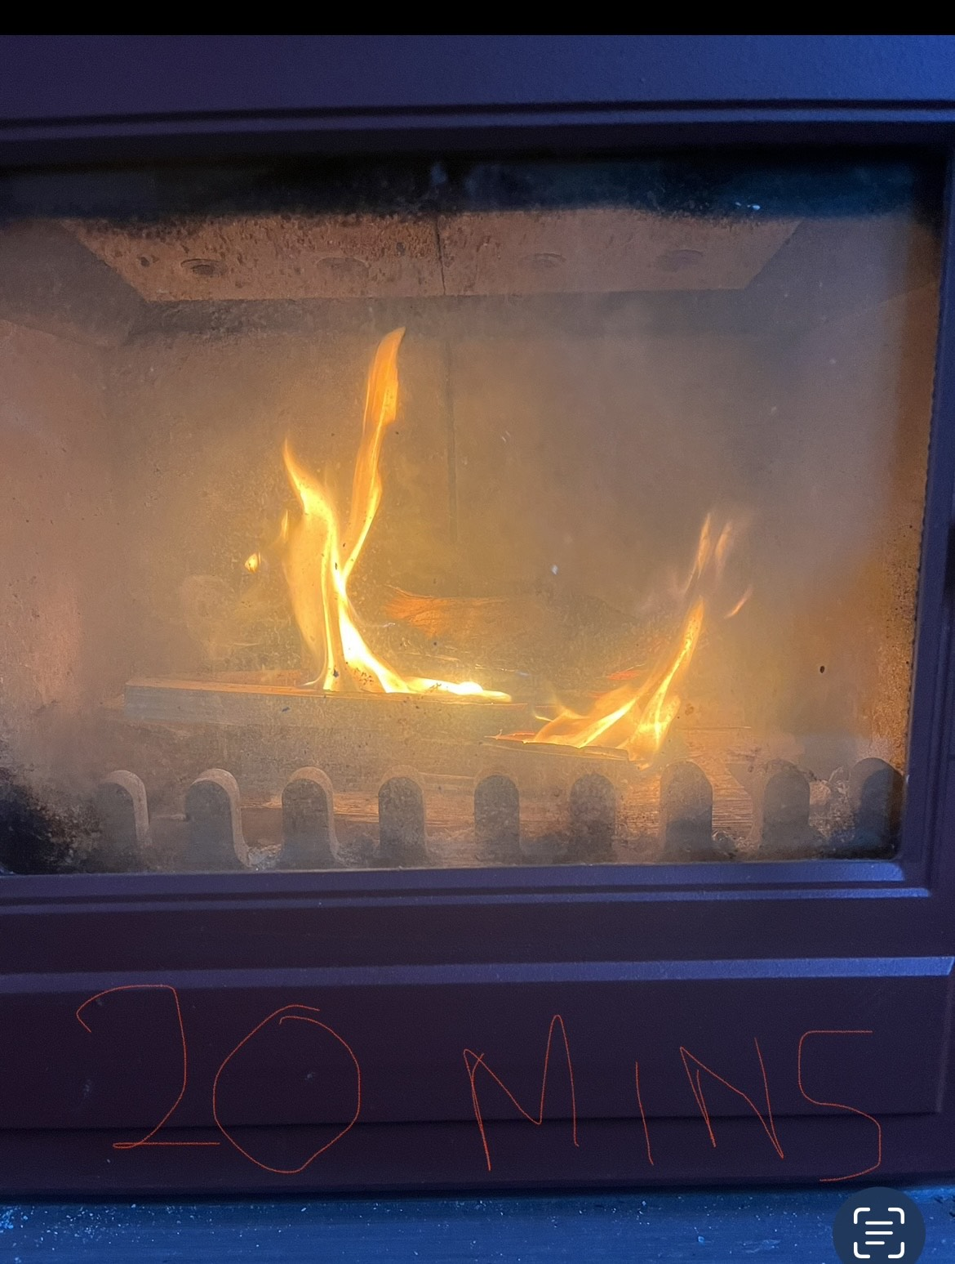

Clock Blithfield 5 at 20 minutes burn time.

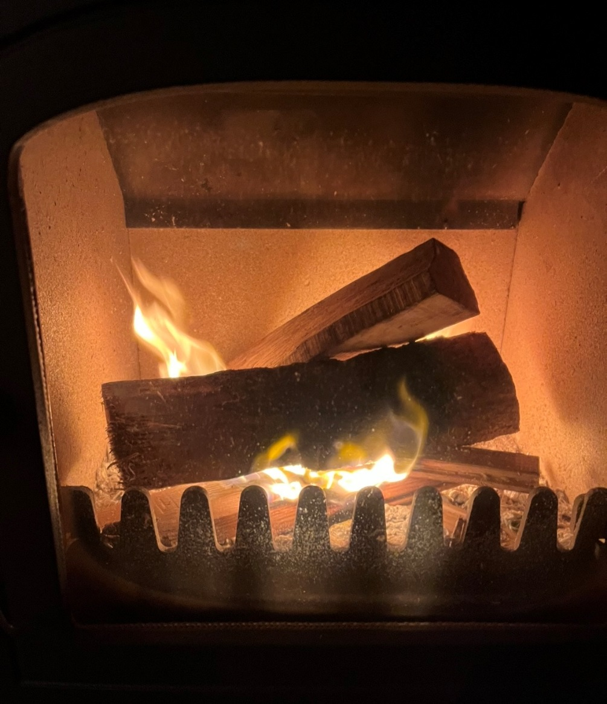

Clearview Pioneer at 20 minutes burn time

**Verdict – Clock Blithfield**

The clock was a disappointment from the start, the colour changed from a ruby red to a washy pink within days of having it installed, we struggled to light it, keep it going and the smoke escape into our home was unbearable, as mentioned above most times we had the patio doors or windows open to allow the smoke out of the room, which negates the point of having the fire alight.

Pro.. …

gave good warmth

Cons…

Smoke escape, house and soft furnishing smelt of fire.

Dirty ash smell even when fire was cold

Hard to light and to keep alight without allowing the smoke to escape so in my mind dangerous to use.

Clock and supplier Customers care non existent

Insufficient burn - clogged chimney and left unburnt logs within fire.

Conclusion..

The Clock does not meet the requirements of a stove, In our minds the eco design does limit what comes from the flue by restricting the draw from the fire as much of what should be extracted stays within the fire itself, spilling out into the house when opening the door or remaining unburnt.

**Verdict - Clearview Pioneer**

Is a pleasure to have and I have fallen in love with having a log burner again, there is no issues on lighting, reloading, keeping it burning with its easy regulation and most importantly no smoke spillage.

Pro

Heat output

Charming looks and features

Ease of lighting

Efficiency in burn and far less fuel used compared to the Clock Blithfield 5

Colour has not faded - we have the mahogany

Excellent customer care and service

All fuel burns away with very little ash left in fire.

Cons…

None

Conclusion

I would recommend this fire and this company to anyone that was either a new comer to stoves or someone who was looking to replace their existing stove.

Clean burn, no smoke escape, a good level of controllable heat.

Before – Clock Blithfield in fireplace

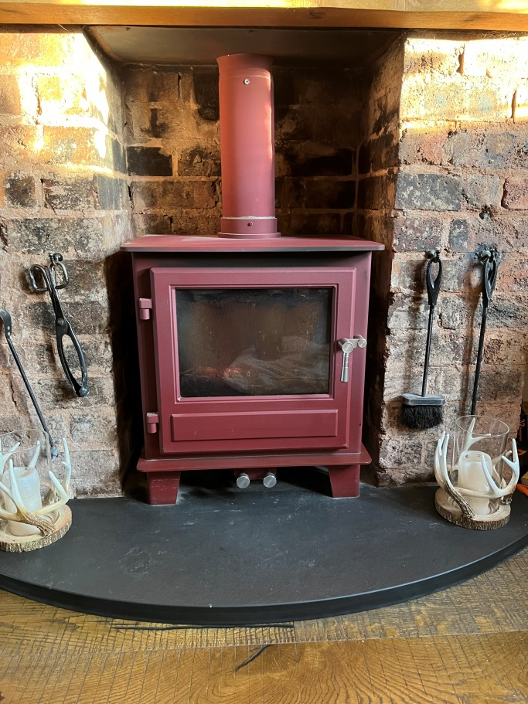

After – Clearview Pioneer 400 in fireplace

